Visual Basic Screenshots – Week 6 – Tom H

1. You can hide certain things of the screen: txtMnu1.Visible = False will make textbox 1 disappear.
2. Changing the size format of the picture you can get in to fit inside the box if the resolution is too big.
3. Copy, Paste, Undo, Cut: txtMnu1.Copy() txtMnu1.Paste() txtMnu1.Undo() txMnu1.Cut()
4. How to check if a menu tab has been checked: mnuViewTextboxes.Checked = Not mnuViewTextboxes.Checked
5. Changes what the open file window title is: openFD.Title = "Open an Text File"
6. Filters different types of files: openFD.Filter = "jpegs|\*.jpg|gifs|\*.gif|Bitmaps|\*.bmp"
7. Tells vb where to initially look for files: openFD.InitialDirectory = "C:\"

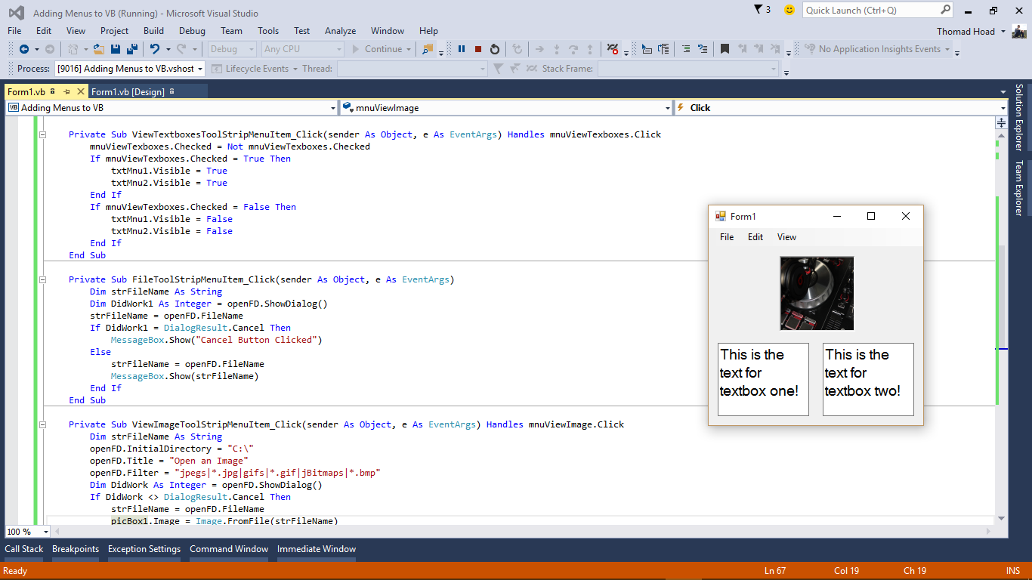 \*Always remember to give objects in your form a name other than the default one!\*